***JUnit Testing with Android Studio***

The following steps will demonstrate how to set up and use Junit in android studio.

***Junit***

Junit is the standard unit testing framework for java. We will add this to our project via the ***build.gradle*** file. Junit is a very powerful tool, but one weakness is that it cannot be used to test any code that actually uses Android classes.

***Robolectric***

Robolectric is a library that injects the missing pieces of Android code, allowing you to run tests on your development machine. We will add this to our project via the ***build.gradle*** file as well.

***Step 1. – Setup build.gradle***

Here is a fresh build.gradle file from a new project:

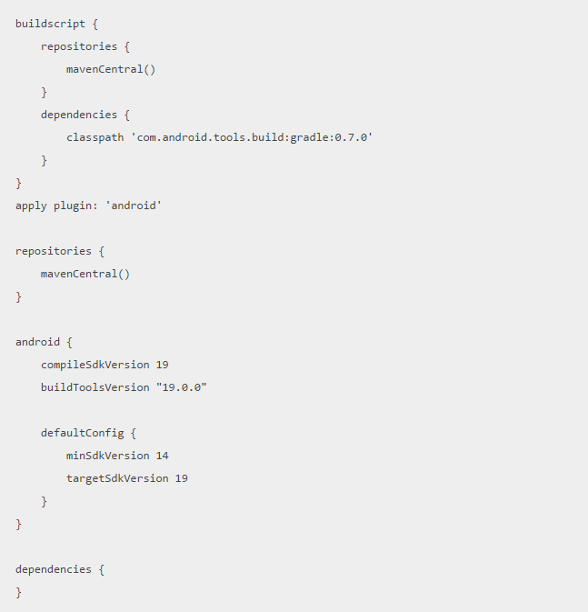

Now let’s make a few additions. We will first add a new build type named unitTest, and then include our JUnit and Robolectrice dependencies.

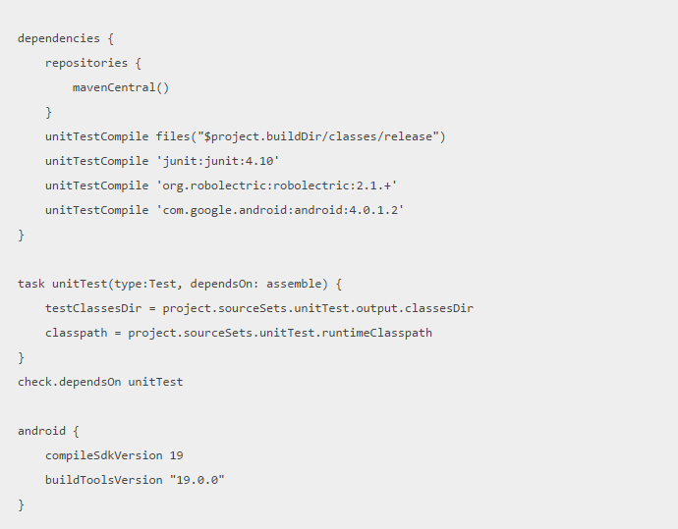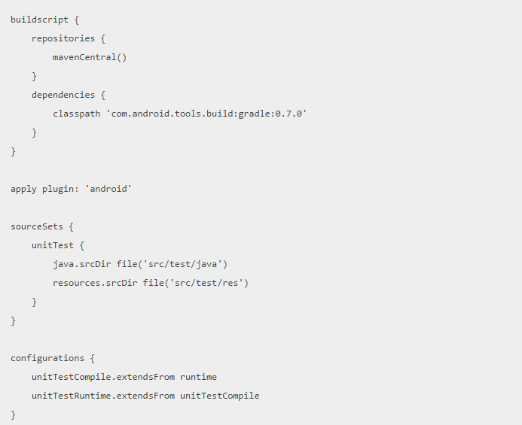

***Step 2 –Add a Test***

You can add a test by creating a test/java directory in the src folder.

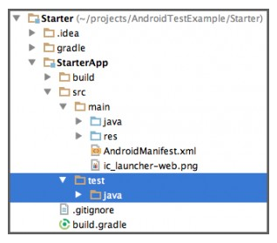

Now let’s add our first test:

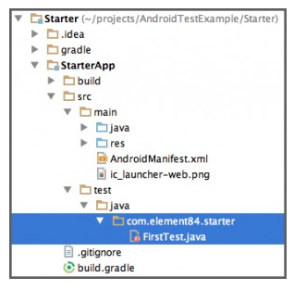

Code for **FirstTest.java:**

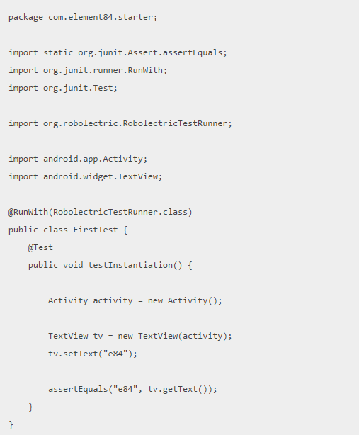

***Step 3 –Run the Test***

Open a terminal to where your project’s **gradlew** sits

    $ cd projects/AndroidTestExample/Starter/

Then run

    $ ./gradlew unitTest

If you receive a permissions error, resolve it with

    $ chmod +x gradlew

***Step 4 – View the Results***

The test results are viewable as an ***html file*** buried in your ***project’s directory.***

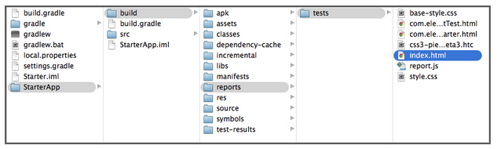

Source: http://blog.element84.com/easy-testing-with-android-studio.html